 | 'GENERAL' RISK ASSESSMENT | DATE PREPARED:

Work Activity Being Assessed |  | Event Details

Table 1 Classification of Risk
Risk Analysis/Priority of Action Matrix

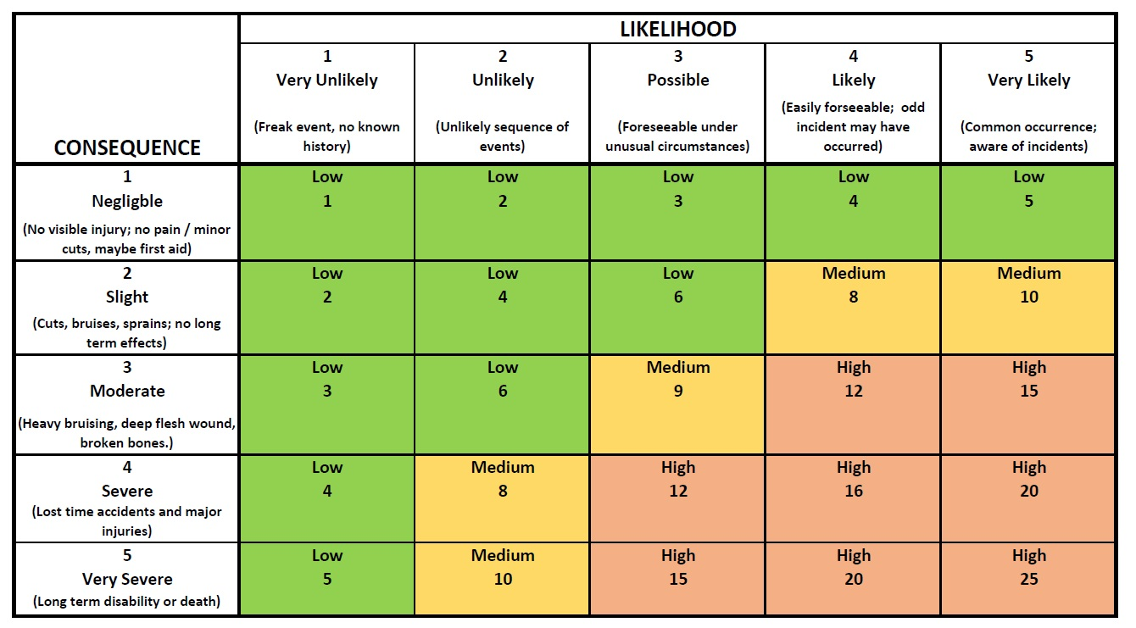
 | Hazards | Consequence x Likelihood = Primary risk based on no controls  C x L = R |  |  | Control Measures | Consequence x Likelihood = Primary risk based on no controls  C x L = R |  |  | Comments / Further Measures
Travel | Slips and trips whilst boarding / exiting vehicle to travel to / from Historic Site | 3 | 3 | 9 | - Leaders to monitor onboarding of vehicle  - Young people to board vehicle in a sensible manner  - Young people made aware of the risks around the vehicles and to pay particular attention in unfamiliar environments  - If using public transport, young people made aware of exiting the vehicle with sufficient time to safely prepare to exit | 3 | 2 | 6
Travel | Vehicles transporting group not meeting legal requirements | 3 | 3 | 9 | - If travelling to / from Historic Site via private vehicles (car, minibus or coach), ensuring that the driver carries all relevant licenses and insurance  - Vehicle to have current MOT and have visual inspection before being driven  - Minimum two leaders per vehicle to meet safeguarding requirements | 3 | 2 | 6
Travel | Group separated on public transport and getting lost | 2 | 4 | 8 | - Leaders to ensure that group stays together where possible, keeping clear from the road or platform edge  - One leader to be at front of the group, and one leader to remain at the back of the group in case of separation  - Where possible whole group to sit down together, if not possible, then to sit in smaller groups not individually  - Group to be counted off the vehicle by a leader | 2 | 2 | 6
Travel | Injury caused by movement in vehicle or sharp braking | 3 | 4 | 12 | - If vehicle is fitted with seat belts, all to wear seat belts  - If using public transport, all young people to be seated, where possible in their own seat  - Young people briefed before the trip to be sensible and follow behaviour expectations  - No movement through vehicles unless required | 3 | 2 | 6
Travel | Slips and trips walking to / from Historic Site | 4 | 3 | 12 | - Leaders to check the route in advance  - Young people to be advised to be extra aware in unfamiliar environments  - One leader to remain at the front of the group to lead and one to remain at the back to ensure all young people remain with group with remaining leaders spread amongst group  - Use pavements where possible, if not then single file  - Leaders to stop traffic when crossing roads – using pelican crossings or pedestrian crossings where available | 4 | 2 | 8
At Historic Site | Inadequate / insufficient supervision of young people |  |  |  | - Ensure sufficient leader ratios – including any additional leaders required for young people with additional needs  - Leaders to be allocated specific tasks or group of young people for supervision
At Historic Site | Fire | 5 | 2 | 10 | - Venue fire safety protocols to be covered in site’s fire risk assessment  - Follow site’s evacuations with leaders doing head count on evacuation  - Leaders to be briefed on process for if evacuated whilst group is in smaller break out groups | 5 | 1 | 5
At Historic Site | Slips / trips / falls around Historic Site | 3 | 3 | 9 | - Sufficient leaders to supervise group to ensure appropriate behaviour  - Appropriate footwear to be worn by all  - Young people advised to be aware in unfamiliar environments  - Before any activities commence, visual check of surroundings and remove any hazards  - Ensure no trailing cables, and any cables taped down safely | 3 | 2 | 6
At Historic Site | Personal safety / getting lost / interactions with general public | 2 | 4 | 8 | - Ensure group is divided into small groups each monitored by an adult. Young people to always remain under supervision of leaders.  - Follow guidance for out and about/getting lost/walking to and from. All young people to be briefed on staying together and have contact details for group if lost. | 2 | 2 | 4
At Historic Site | Cuts / injury from activities or crafts | 3 | 3 | 9 | - Only activities deemed suitable for group of young people to be undertaken.  - Teach safe use of sharp implements (scissors, needles etc)  - Adults to undertake more complicated cutting requiring e.g. craft knives.  - Suitable footwear and clothing to be worn  - Ensure sufficient leaders for the activity and the number of young people including any additional leaders to support those with additional needs | 3 | 2 | 6
At Historic Site | Cooking:  - Burns / scolds / fire  - Food poisoning  - Allergic reactions | 4 | 4 | 12 | - All sharp implements to be stored safely e.g. in box with lid or knife block.  - Instruct young people in sensible use of peelers, knives, scissors and tins.  - Ensure adequate adult supervision especially near cookers/boilers/hot water etc.  - Oven gloves to be used when moving hot dishes.  - Water spills to be mopped up immediately to avoid slipping.  - All surfaces to be cleaned regularly with anti-bacterial spray.  - Leaders to be aware of allergies of any of the young people | 4 | 2 | 8
At Historic Site | Practical Activities (to complete with specific activities during visit)
Duration of Trip | Delay in medical attention in case of accident | 4 | 4 | 12 | - Minimum one first aid trained leader  - First aid kit to be appropriately stocked with relevant items  - If accident is more serious and needs future attention than first aider, immediately call 999 | 4 | 1 | 4
Collection of Young People | Personal safety | 2 | 4 | 8 | - Leader to monitor departures and ensure that members are escorted from  - building by known adult.  - Ask for written permission/notification where members are to walk home alone.  - Ensure external lights are on in dark weather/nights. | 2 | 2 | 4

